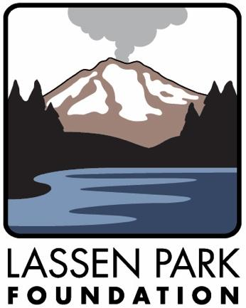

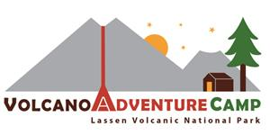

2024 Trip Planning Information

& Group Leader Resources

Table of Contents
Table of Contents 1
Welcome and Important Background Information 2
Welcome to the Volcano Adventure Camp! 2
Construction This Summer 2
What is the Volcano Adventure Camp? 3
Canvas Cabins, Picnic Pavilions, Campfire Circles 4
Volcano Adventure Camp Map 5
Lassen Volcanic National Park Information 6
Sample Youth Camp Itinerary 2021 7
Directions for Driving Around the Park 10
Volcano Adventure Camp Planning Checklist 12
Emergency Information 13

The Volcano Adventure Camp was built through a partnership between the National Park Service and Lassen Park Foundation with special thanks to The McConnell Foundation and the Volgenau Foundation.

Welcome and Important Background Information
Congratulations on receiving a Youth Camping grant from the Lassen Park Foundation! We are so glad that this will help make it possible for your group to experience Lassen Volcanic National Park.
Welcome to the Volcano Adventure Camp!
https://www.nps.gov/lavo/planyourvisit/directions.htm
Your group will be staying at the Volcano Adventure Camp (VAC). The VAC is a youth camping facility located inside Lassen Volcanic National Park. This designated facility provides opportunities for a wide range of youth organizations including school groups, other educational groups, and scouting organizations to introduce young visitors to their national park. The facility was completed in 2016—just in time to celebrate the 100th birthday of Lassen and the National Park Service.
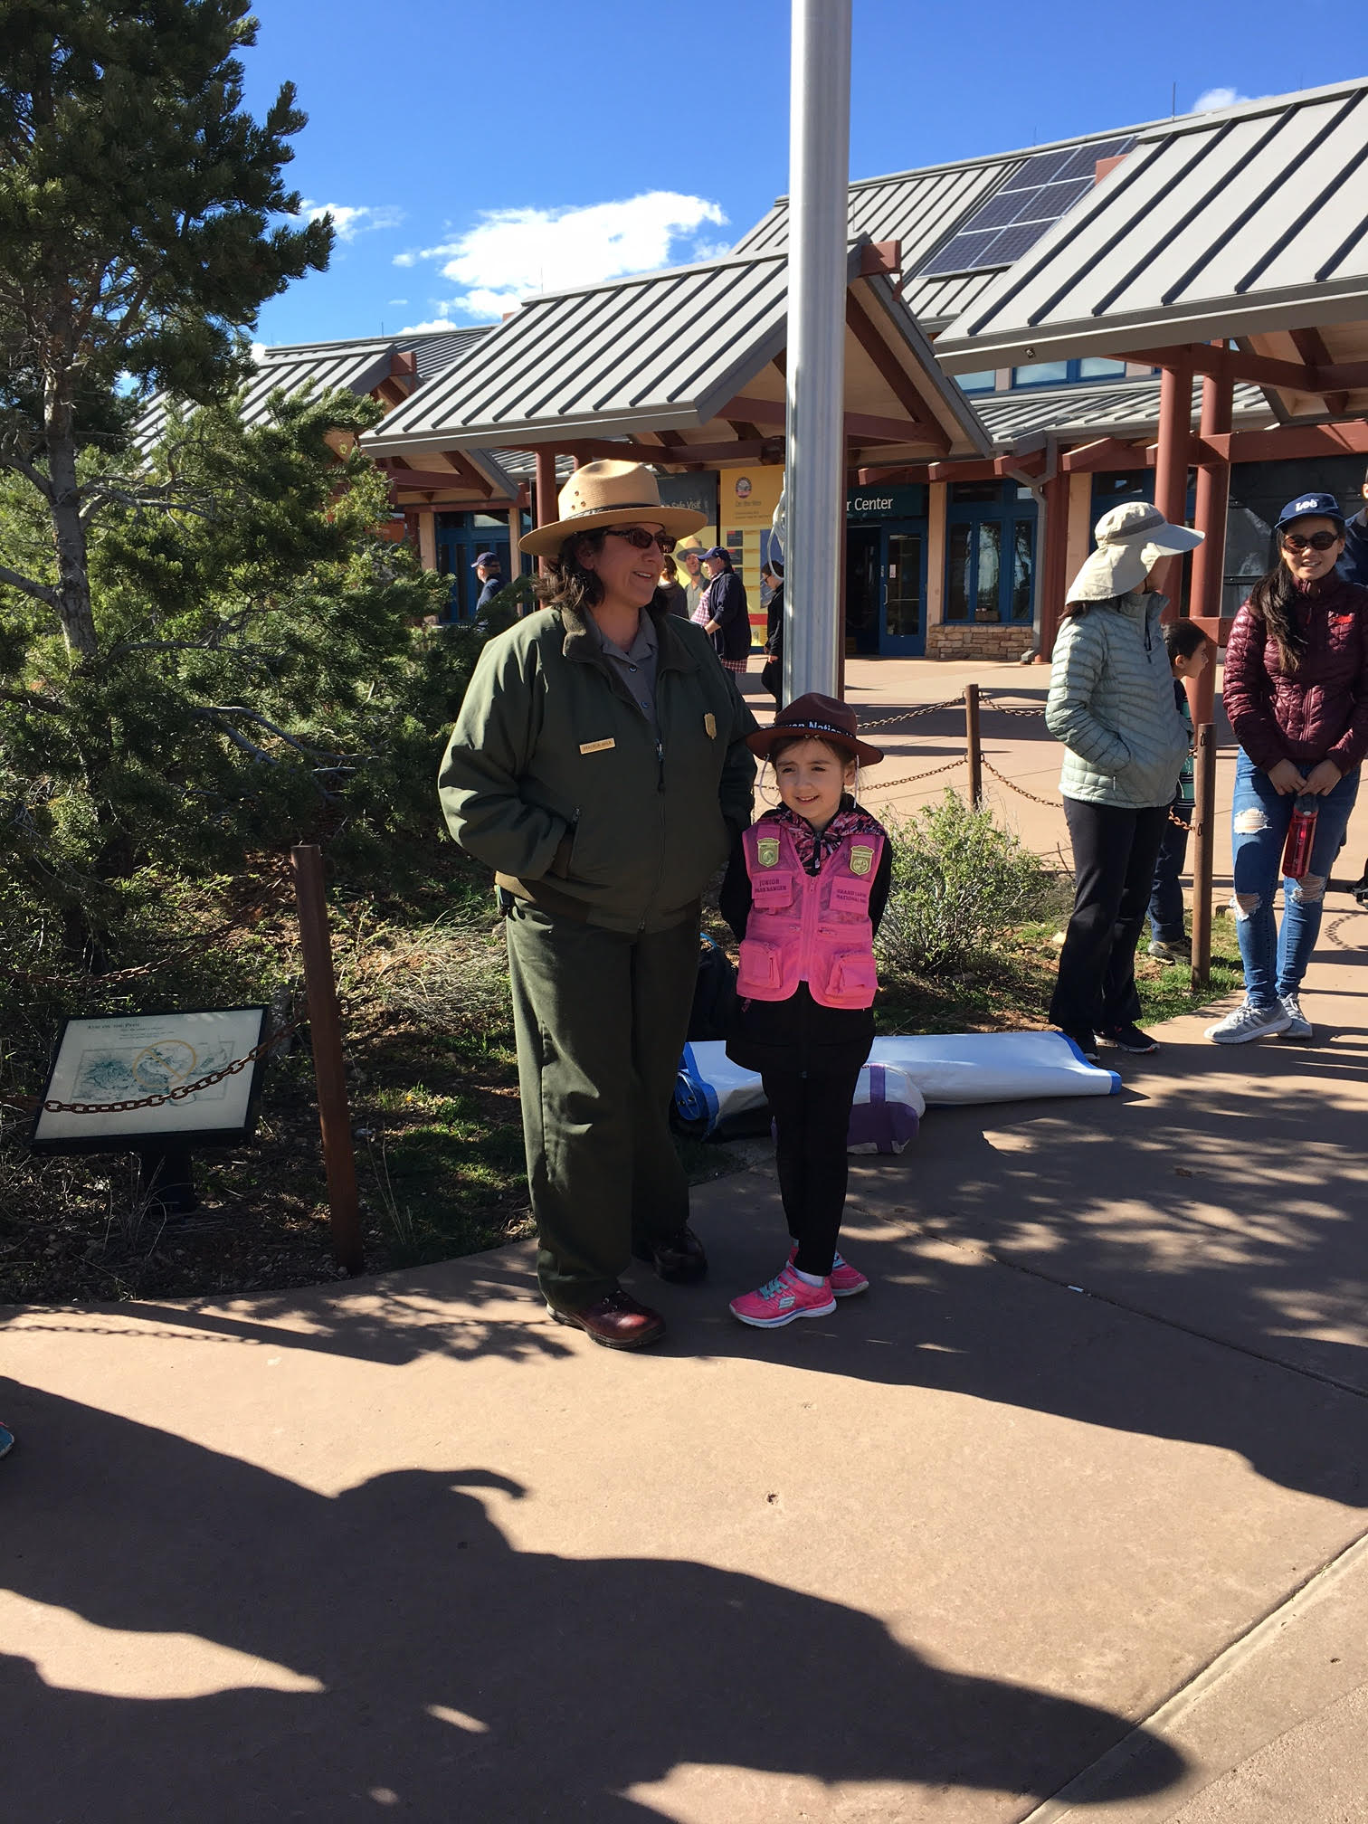
The primary National Park Service coordinator for your group’s youth camping experience will be Graciela Avila (photo and contact information below).

When arriving at the VAC, the youth camping ranger will meet your group and facilitate a welcome activity (see page 6). The group leader will have you sign an arrival checklist indicating your acknowledgement of the need to manage the behavior of the campers and chaperones while at the VAC. All structures (i.e. tent cabins, pavilion) and equipment (i.e. cots, tables, etc.) need to be returned to the National Park Service in the same condition that you receive them.
New this year! Four tents off to the side of the youth tents will be used by university groups doing research in the park. Youth camp rangers will notify your group if there will be researchers there at the same time as your group. Rangers may ask if you’d like to arrange for a time when students can talk with researchers about their work. Researchers will be sharing the use of bathroom and shower buildings at the VAC.

What is the Volcano Adventure Camp?
The Volcano Adventure Camp supports low-cost group camping experiences by reducing the amount of equipment required and providing necessary amenities for first-time campers. The following facilities and items are provided for groups at the VAC: canvas cabins, stacked cots, picnic pavilions, campfire circles, hot showers, vault toilets, trash and recycling, cleaning supplies (brooms & dustpans), and tent sites.
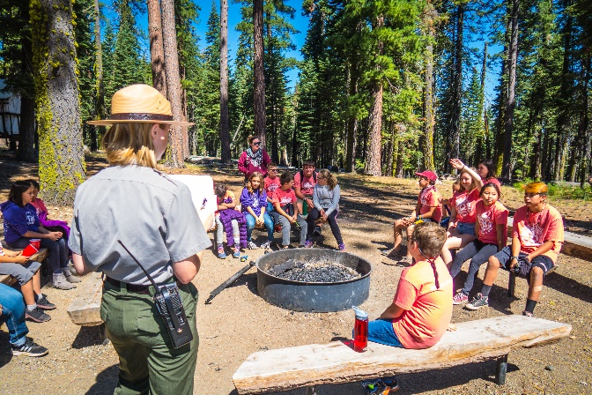
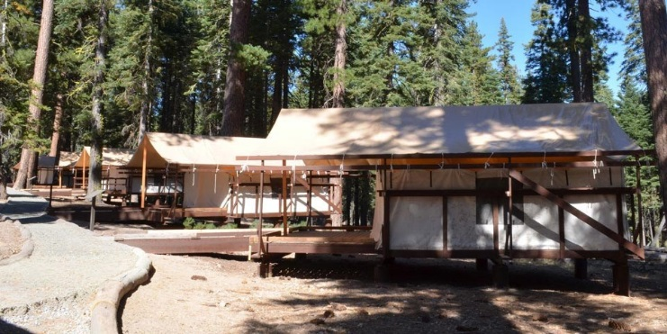

Above: Campfire Circle

Above: Canvas Cabins

Canvas Cabins, Picnic Pavilions, Campfire Circles
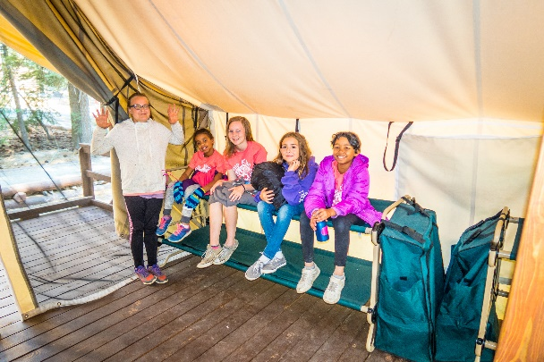
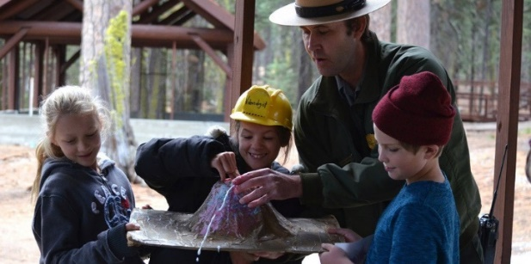
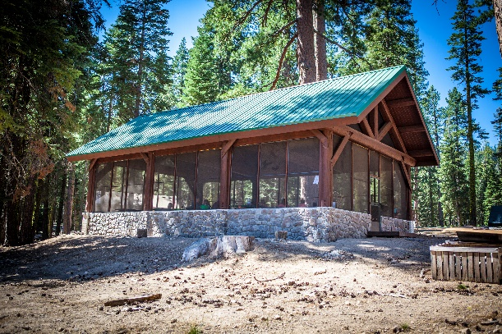
- Ten (10) cabins (in two groups of five) each sleep up to 8 people.

- Four (4) tent pads that can each accommodate up to 12 tent campers.
- Two covered and screened pavilions (image left) each contain a cold-water sink for dishwashing, two propane barbeque grills (propane provided) and seven large tables.
- Bear lockers for food storage are close to each pavilion.
- Two (s) fire circles provide seating and space for programs and activities.
Cots - Each cabin contains eight cots (image left).

Ranger-led Programs - Guided programs and activities are provided to facilitate the immersive learning experience (image left).

Volcano Adventure Camp Map
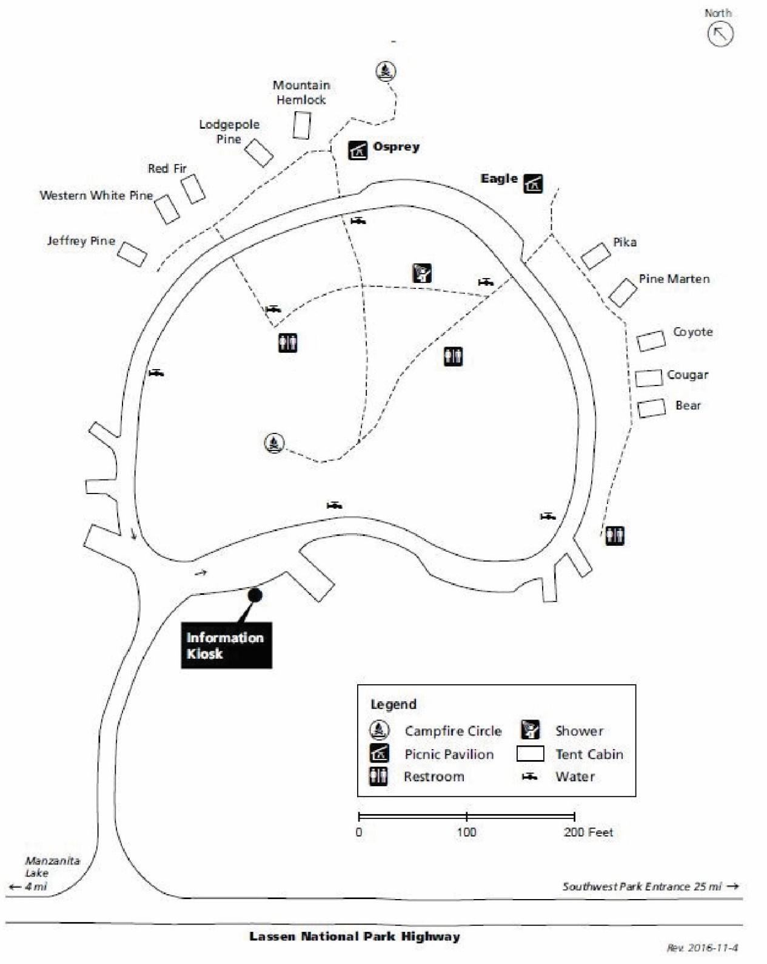
The sign on the park highway at the entrance to the camp reads:

Lassen Volcanic National Park Information
Volcano Adventure Youth Camp
Reservations Only
(Home page: nps.gov/lavo)
Lassen Volcanic National Park, established in 1916, is located in northeastern California in portions of Shasta, Lassen, Plumas, and Tehama counties. The 106,372-acre park is located about fifty miles east of both Red Bluff and Redding and is within a day's drive of two major California metropolitan centers, the Sacramento and San Francisco Bay areas.
The park accommodates about 500,000 visits each year, providing opportunities for visitors to learn about volcanism, culture, and other park phenomena. Visitors also enjoy various recreational pursuits such as sightseeing, camping, picnicking, and hiking. Over 75 percent of the park is congressionally designated wilderness.

The National Park Service exists to preserve the natural and cultural resources and facilitate visitor experiences at national park sites such as Lassen Volcanic. Thank you for bringing your youth group to this amazing resource, and for helping to share the message that our public lands and waters belong to everyone!

Sample Youth Camp Itinerary 2024
The following itinerary is intended as a sample only. You can design your trip by choosing from a variety of ranger programs or self-led activities. This is a “Five Day” itinerary. Your trip may be either shorter or longer. We encourage groups to engage in a ranger led activity daily. The Youth Camp Ranger is available to help you plan your itinerary. Please note groups may check in after 1pm on the day of arrival and need to vacate camp before 11am on the day of departure.
Day One- Arrival (1pm) — Park sites: Volcano Adventure Camp
Upon arrival at Lassen Volcanic National Park, the Youth Camp Ranger will meet you at the Volcano Adventure Camp and provide an introductory experience for you and your campers!
Orientation (required) — Youth Camp Ranger-led Activity: The group will review safety and behavioral expectations. The group will learn what a national park is and why Lassen is protected and preserved as an important natural and cultural resource.
Volcano Adventure! The Four Types of Volcanoes at Lassen. Youth Camp Ranger-led Activity: This will consist of a volcano demonstration where the ranger engages the kids with various ways of modeling volcanic eruptions.
Get acquainted with the Volcano Adventure Camp and Lassen! The Youth Camp Rangers will provide orientation information, schedule a time for your orientation program with you, and/or directions as needed (this will also be communicated prior to your arrival at the park). Depending on what time youarrive at the park, you may just want to unpack and get set up in your tent cabins, utilize the pavilions to make a meal, or even go and enjoy a self-led hike on a park trail. Please be in the camp at your scheduled orientation program time.

Day Two—Park Sites: Devastated Area, Mill Creek Falls Trail, and Volcano Adventure Camp
Morning—Youth Camp Ranger-led Activity: Campers will participate in in a ranger-led activity at the Volcano Adventure Camp, or another unique park site.
Example: “Devastated Area—Rock Cycles”
The Youth Camp Ranger meets your group at the Devastated Area and they participate in an activity where they learn about how the Devastated Area was formed through dramatic volcanic eruptions and other geologic processes.
Late Morning/Afternoon—Enjoy Your Own Hike! Group leaders will be provided with information and materials related to the site you choose for your self-led hike.
Example: Mill Creek Falls Trail
Group leaders will utilize materials and waysides to provide campers with a nature hike and first-hand experience of a red fir forest. This 3.8-mile round-trip hike would be an example of a “moderate” hike.
Evening— Enjoy dinner at the Volcano Adventure camp and your own campfire with the kids! Note: Fire restrictions and the collection and burning of wood will be clarified by the Youth Camp Ranger.

Day Three—Park Sites: Lassen Peak, Kohm Yah-mah-nee Parking Lot
Morning—Enjoy Your Own Hike! Group leaders will be provided with information and materials related to the site you choose for your self-led hike.
Example: “Lassen Peak Trail”
Group leaders will utilize materials and waysides to provide campers with a rigorous nature hike, and an opportunity to summit one of the largest plug dome volcanoes in the world! This hike is a strenuous 5-mile hike with a 2000 ft. elevation gain to a summit of 10,400 ft.
Afternoon—Not far from the Lassen Peak trailhead is our southwest entrance and the Kohm Yah-mah-nee Visitor Center. Visit the Kohm Yah-mah-nee Visitor Center to obtain Junior Ranger books, check out the many displays, and watch the park video. Mill Creek Falls Trailhead is located off the parking lot, and Sulfur Works is a short 1-mile drive away.
“Mill Creek Falls Hike”
Rises and falls through the red fir forest to an overlook of the falls. Continue across the creek to reach the top of the falls. Trailhead behind Kohm Yah-mah-nee Amphitheater. This hike is a moderately strenuous 3.2-mile hike with a 416 ft. elevation gain to the falls and overlook. The area has also been affected by recent fires so check at the visitor center for possible hazards.
Evening—Enjoy dinner at the Volcano Adventure camp and your own campfire with the kids! Note: Fire restrictions and the collection and burning of wood will be clarified by the Youth Camp Ranger.

Day Four—Park Site: Manzanita Lake, Reflection Lake/Lily Pond Trail
Morning—Youth Camp Ranger-led Activity: Campers will participate in a ranger-led activity at the Volcano Adventure Camp, or another unique park site!
Example: “Ecosystems”
This ranger-led activity consists of a walk around Manzanita Lake and an investigation and discussion of the animals, plants, and other natural aspects of this ecosystem. Approximately 2 miles, an “Easy” hike.
Late Morning/Afternoon—Enjoy your own activities at Manzanita Lake, Reflection Lake, or take a stroll on the gentle, beautiful Lily Pond Trail (an easy, 3/4-mile loop). *At Manzanita Lake, you may rent a kayak, paddle board, or simply wade in the water.
*Note: Water activities must be led by group leaders and will not be facilitated by a National Park Service ranger.
Afternoon— The Youth Camp Ranger will meet you and facilitate a discussion with your campers that will be focused on their trip to Lassen and how they can bring what they experienced and learned back home with them. Campers will be reminded that Lassen is one of over 400 national park sites, and each park belongs to them as well as all other visitors. A discussion of how best to actively preserve nature and culture will be included in this closing activity.
An evaluation survey will be conducted by a Youth Camp Ranger as part of this closing activity.
Evening— Enjoy dinner at the Volcano Adventure camp and your own campfire with the kids! Note: Fire restrictions and the collection and burning of wood will be clarified by the Youth Camp Ranger.

Day Five— Departure (11am) Park Site: Volcano Adventure Camp
Early morning rise and pack up your gear as the facility must be vacated by 11am to get ready for the next group of campers. Please be packed up and ready to go by the scheduled time for your exit program. Your group may enjoy the rest of the park throughout the day.
Maps: For maps, please visit- nps.gov/lavo/planyourvisit/maps.htm

Directions for Driving Around the Park
(Directions Website: nps.gov/lavo/planyourvisit/directions.htm)
Lassen Volcanic National Park is located in northern California, approximately three hours northeast of Sacramento. The park is accessed via Hwy 44 (to the north) or Hwy 36 (to the south). From the east (i.e. Reno), the park can be accessed from Hwy 36 to Hwy 44. The park highway may be closed in early or late summer because of snow. Please be sure to check the park website, or contact the Youth Camp Ranger, for park road closures.
The most direct route to the Volcano Adventure Camp would be to access the park from Hwy 44 and enter the park through the Manzanita Lake entrance. Continue south along the park road (Lassen Volcanic National Park Highway/Hwy 89) for approximately five miles. The Volcano Adventure Camp site will be on your left—look for signs (Youth Camp) and tent cabins.
If accessing the park from Hwy 36, take Hwy. 89 to the southwest entrance at the Kohm Yah-mah-nee Visitor Center. Continue north along the park road (Lassen Volcanic National Park Highway/Hwy 89) for approximately 25 miles. The Volcano Adventure Camp site will be on your right—look for signs (Youth Camp) and tent cabins.
Here are the addresses and phone numbers for our park visitor centers. These may be staffed from 9 AM – 5 PM every day of the week during the summer season. Please contact Lassen Park Foundation if you have difficulty obtaining the information you need (530) 378-5199 or info@lassenparkfoundation.org. The park website will also be updated regularly to provide closure information on visitor centers.

Loomis Museum, (530) 595-6140
29489 Lassen National Park Hwy
Shingletown, CA 96088

Kohm Yah-mah-nee Visitor Center, (530) 595-4480
21820 Lassen National Park Hwy
Mineral, CA 96063

For additional assistance directions to the park please visit the following webpage: nps.gov/lavo/planyourvisit/directions.htm

Volcano Adventure Camp Planning Checklist
Please use this checklist or create your own to help you prepare for a trip to Lassen Volcanic National Park. We look forward to your visit! The
Safety: Please remind your students and chaperones that they are entering into a national park and everything here is to be protected. This is a natural environment where they will see wildlife, plants and rocks which should not be harmed or removed from the park. Potential hazards in the area include bees, wasps, trip and fall hazards. Students will learn how to avoid these hazards and be alert to other safety concerns. Students with allergies should bring their medication, especially for bee and wasp stings. Rangers DO NOT provide medication to park visitors. It is recommended to bring a first aid kit, or multiple first aid kits for chaperones/hike leaders.
- Check the Weather: So that you know what to plan and pack for, check the weather before you leave at 7-Day Forecast 40.54N 121.56W (weather.gov).
- Chaperones: Please inform chaperones that they will be visiting a site where they are responsible for the safety and supervision of the campers they are assigned. Please ensure that one adult sleeps in each tent cabin when campers are under age 18.
- Clothing: Please have students and chaperones bring and wear appropriate clothing for predicted weather and to be prepared for the weather to change. Students and chaperones should wear long pants, hats, and close-toed shoes while hiking. If possible, dress in layers and use sunscreen. Prepare for cold nights and mornings.
Food and Water: You are responsible for providing all meals and snacks. We also recommend that students bring their own reusable water bottles. They can refill water bottles at the park.
Cooking: Coolers/other containers with food, Plates/bowls/cups, utensils, trash bags, dish soap, pots/pans. [Think about and make a list of other cooking/meal preparation items you need] The propane BBQs do not have burners. A small campstove for heating water will be useful.
Sleeping Items/Equip.: WARM sleeping bags, sleeping pads, pillows, extra blankets. Each tent cabin will have eight (8) cots total.
Showers/Restrooms (no running water in restrooms): Shower shoes/flip flops, towels, soap in a case/body wash, shampoo/conditioner, toothbrush/toothpaste, other toiletries. Each camper should have a sealable bag for storing toiletries in bear boxes. Solar powered hot water in the showers, which rangers may need to reset power for occasionally.
Stewardship (Taking Care of VAC and Lassen): Please remind students to not feed any of the animals in the park including chipmunks and squirrels, and to dispose of all pieces of trash. Students should be instructed not to have any food or beverages in the tent cabins at any time. Squirrels and chipmunks will get into tent cabins, and have been known to destroy backpacks while getting into food left in tent cabins. In the cooking pavilions, all food waste and grease (cooled) must go into the trash cans as they can cause problems for sink drains.
Other Necessities: Flashlights (there are no lights at the VAC), extra batteries, lanterns, sunscreen, insect repellent, hiking backpacks, sunglasses, cameras, refillable water bottles for each camper, and hand sanitizer [think about what else you might need or want while staying at the VAC].

Emergency Information
Be Prepared. Know if any of your campers or chaperones have medical conditions and ensure that they have their medications. Identify any group leaders or chaperones who have emergency medical service qualifications (i.e. first aid, emergency medical responder/technician, nurse, etc.). Bring first aid kits, and ensure that your chaperones communicate appropriate safety messages and are prepared to respond and/or communicate during an emergency. Rangers will not provide medical supplies or equipment to park visitors so please bring your own.
National Park Service Emergency Response. Emergency medical and Search and Rescue rangers and other professionals will respond in the event of an emergency.
Communicating an Emergency. There may be an NPS Volunteer VAC camp host on site with access to a park radio. Find them if an emergency situation arises. There is minimal cellular service at the Volcano Adventure Camp. There are other sites in Lassen Volcanic National Park where you may have cell phone coverage. If there is no camp host available at the VAC There is reasonably reliable cell phone service at pull-out 13, approximately 3 miles from camp. You are encouraged to bring your cell phone when hiking. Turn off your phone unless you need to make an emergency call (this will preserve the battery).
Alternative in the event of an emergency: Dial 911 to report an emergency. From the Volcano Adventure Camp, the nearest location of a campground host is at Manzanita Lake Campground (approximately 5 miles north of the Volcano Adventure Camp). You may contact the campground host(s) at the beginning of A-Loop sites 1-A and 1-B (see map on the following page). Pay phones are available outside the Manzanita Lake Camper Store and Loomis Museum.
Know Your Location. When hiking and visiting other park locations, it is important for group leaders and chaperones to know the names of trails and park sites that you are experiencing. This will help rangers respond in the event of an emergency. Refer to maps and/or ask for clarification from the youth camp ranger upon your arrival to the park.

Manzanita Lake Temperatures

Plan for the Weather/Altitude: Weather can change rapidly or might be very different from where you are located. To find out what the local weather is during your trip, please refer to weather.com or any other weather app and use “Manzanita Lake,” or “Lassen Volcanic National Park” for the location. Additionally, please realize that many areas of the park are at significantly higher elevation than most campers are used to. Plan to take your time on hikes and watch campers for signs of altitude sickness (nausea, dizziness, headaches).

